Please return completed form to:
MCHS Foundation
1000 N Oak Ave, 1R1
Marshfield, WI 54449-5777
giving@marshfieldclinic.org
Phone: 715-387-9249/800-858-5220
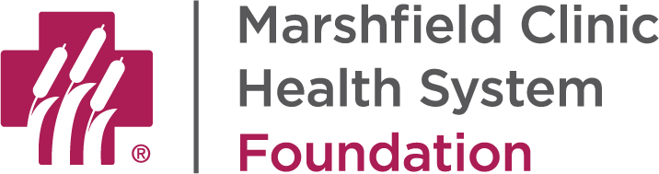

DOEGE LEGACY SOCIETY ENROLLMENT FORM

Because of my/our special regard for Marshfield Clinic Health System and its patient care, research and education mission and realizing the importance of planned gifts to the Clinic’s future, I/we have made the following provisions for Marshfield Clinic Health System Foundation in my/our estate plan(s):

1. DESCRIPTION OF LEGACY GIFT:
a gift of a specific amount
a gift of a specific item of property (please describe item):
____________________________________________________________________________
a percentage gift of the residue of my estate: _______%

My/our gift is in:
will
revocable trust
irrevocable trust
charitable trust

life insurance beneficiary designation
retirement plan beneficiary designation
bank account beneficiary designation
(CD, money market, etc.)
other: __________________________

2. CURRENT VALUE OF LEGACY GIFT:
The approximate current value of my/our gift is $ .
NOTE: Marshfield Clinic Health System Foundation uses this information to anticipate future gifts for budgeting and forecasting purposes. This is not a binding obligation to gift the stated amount to Marshfield Clinic Health System Foundation.

3. USE OF LEGACY GIFT:
My/our gift is to be used for the greatest need.
My/our gift is designated to be used for:

NOTE: If your gift is intended to create a named endowment, fund, program or space, please contact the Marshfield Clinic Health System Foundation for information regarding Marshfield Clinic Health System’s naming policies and practices.

4. RECOGNITION FOR LEGACY GIFT:
Please list my/our name(s) on the Doege Legacy Society donor wall and in published
Doege Legacy Society listings as:
I/we wish to remain anonymous during my/our lifetime(s), then my/our names should be
listed as: ________________________________________________
I/we wish to remain anonymous during my/our lifetime(s) and after the gift matures.

By signing this enrollment form, I/we affirm my/our commitment to Marshfield Clinic Health System Foundation. However, this enrollment form shall not be binding upon my/our estate, and the information contained herein shall be used for Marshfield Clinic Health System Foundation purposes only.

_________________________________________________ ______________ _____________
Name Birthdate Date Signed

_________________________________________________ ______________ _____________
Name (if two donors) Birthdate Date Signed

MCHS Foundation Staff Use

_________________________________________ ______________
Received By Date Rec’d

